**FACULTY OF COMPUTING**



**Database Systems**

**[Lab no. 9]**

Submitted To: Ma’am Ayesha Akram

Submitted From: Nida Iqbal

SAP ID: 58976

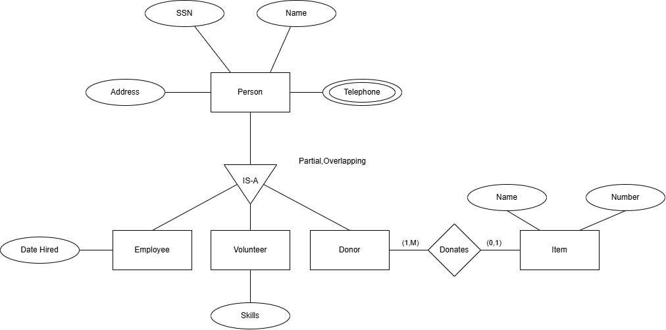

Here, Partial refers to partial participation meaning a person need not belong to any of the three subclasses and overlapping means that a person can belong to more than one subclasses at the same time. For Donor (1:M) means that 1 donation is compulsory and a donor can make many donations. As for an item it doesn’t need to have donors but it can have one donor.